Purpose:
This document outlines the method used to account for emissions from blowdown venting to incorporate in the 2017 Uinta Basin Emission Inventory (UBEI2017) and the changes estimated from findings in the Uinta Basin Composition Study to reflect in UBEI2017-Update.

Background:
The Uinta Basin Oil & Gas Emission Inventory (UBEI) is made up of two main components: (1) Operator Workbooks where operators provide prescribed data elements and emission estimates, and (2) Gap-Filling for emissions sources not covered in the Operator Workbooks. Operators annually report to EPA’s Greenhouse Gas Reporting Program, subpart W (Petroleum and Natural Gas Systems), methane emissions and activity counts for blowdown vent stacks.
For onshore petroleum and natural gas gathering and boosting activities, blowdown vent stacks equipment or event types are grouped into the following seven categories: Facility piping (i.e., piping within the facility boundary other than physical volumes associated with distribution pipelines), pipeline venting (i.e., physical volumes associated with distribution pipelines vented within the facility boundary), compressors, scrubbers/strainers, pig launchers and receivers, emergency shutdowns (this category includes emergency shutdown blowdown emissions regardless of equipment type), and all other equipment with a physical volume greater than or equal to 50 cubic feet. If a blowdown event resulted in emissions from multiple equipment types and the emissions cannot be apportioned to the different equipment types, then the blowdown event is categorized as the equipment type that represented the largest portion of the emissions for the blowdown event.

Method:
- From the EPA Greenhouse Gas Reporting Program, subpart W reporting from operators in the Uinta Basin, obtain the activity levels and resultant methane emissions (reported in metric tons). For Reporting Year 2017, operators in the Uinta Basin reported the following for the seven categories of blowdown vent activities:
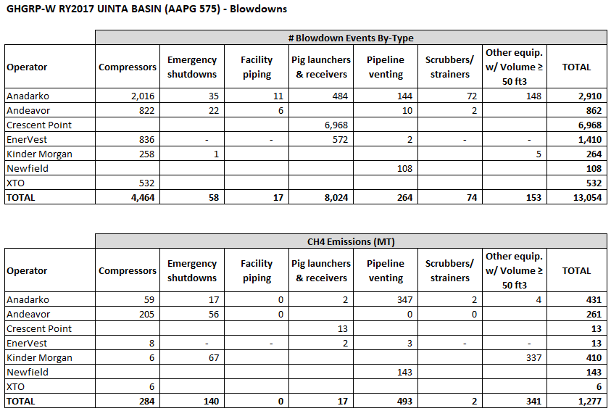
There is not a sub-basin (i.e. county) breakdown of this data.
- Obtain speciation data for a ratio of methane-to-VOC weight percent (Wt.%) for blowdowns of equipment and piping.
  - For UBEI2017:
From the 2014 UBEI, calculate the weighted average (based on # of facilities) of speciated gas streams provided by operators for ‘produced natural gas composition’ from oil and gas production to use as a surrogate ratio of methane-to-VOC emissions for the blowdowns from equipment and the pigging of gas gathering pipelines. From the weighted average of ‘produced natural gas composition’, the weight percent (mass of constituent/mass of whole gas) of methane (CH4) is 0.6849 and of VOCs is 0.1979.
$$\frac{ 0.1979× \frac{VOC ton}{whole gas ton}}{ 0.6849×\frac{CH4 ton}{whole gas ton} × \frac{\left(0.907185\right) MT}{ton}} =0.2889 \frac{VOC ton}{CH4 MT}$$
  - For UBEI2107-Update based on UBCS findings:
From the UBCS, use the average speciated “Raw Gas: Oil Wells” gas stream derived from 50 oil wellpads where gas samples were collected off the separators and analyzed and the “Raw Gas: Gas Wells” gas stream derived from 17 gas wellpads where gas samples were collected off the separators and analyzed. The UBCS speciation profiles are shown below:
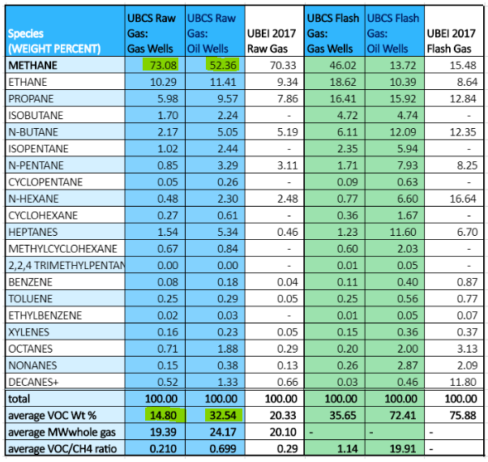
For blowdowns in oil production regions use the weighted average of “Raw Gas: Oil Wells”, the weight fraction of methane (CH4) is 0.5236 and of VOCs is 0.3254.
$$\frac{ 0.3254× \frac{VOC ton}{whole gas ton}}{ 0.5236×\frac{CH4 ton}{whole gas ton} × \frac{\left(0.907185\right) MT}{ton}} =0.6850 \frac{VOC ton}{CH4 MT}$$gas production regions use the weighted average of “Raw Gas: Gas Wells”, the weight fraction of methane (CH4) is 0.7308 and of VOCs is 0.1480.
$$\frac{ 0.1480× \frac{VOC ton}{whole gas ton}}{ 0.7308×\frac{CH4 ton}{whole gas ton} × \frac{\left(0.907185\right) MT}{ton}} =0.2232 \frac{VOC ton}{CH4 MT}$$Allocate the GHGRP-W blowdown data to either oil producing regions or gas producing regions as follows:
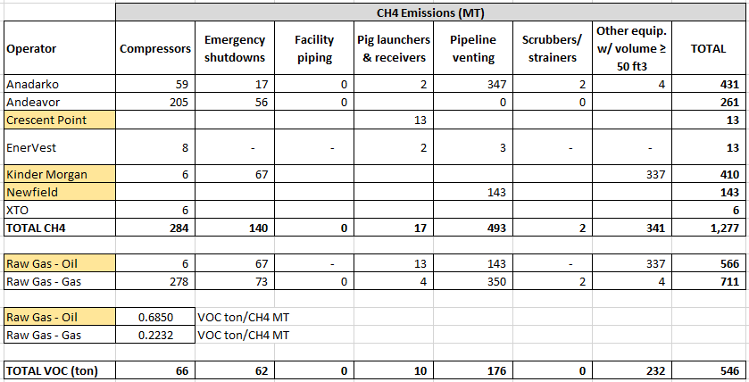
- Calculate VOC emissions from blowdowns in 2017.
  - For UBEI2017:
$$1,277 MT CH4 ×0.2889 \frac{VOC ton}{CH4 MT } =369 ton VOC$$
  - For UBEI2107-Update based on UBCS findings:
In oil regions:
$$566 MT CH4 ×0.6850 \frac{VOC ton}{CH4 MT } =388 ton VOC \\ In gas regions: \\ 711 MT CH4 ×0.2232 \frac{VOC ton}{CH4 MT } =158 ton VOC$$Total for Uinta Basin: 388 + 158 = 546 Tons VOC

Results:
We propose to adjust the UBEI2017 ‘Gap-Filling’ line item, blowdowns, by replacing 369 TPY VOC with 546 TPY VOC (+177 TPY).

Uinta Basin Composition Study Comprehensive Final Report, Utah Division of Air Quality. March 31, 2020 https://documents.deq.utah.gov/air-quality/planning/technical-analysis/DAQ-2020-004826.pdf
40 CFR Part 98, §98.233(i)

